**Configuring GitHub Hook to Jenkins:**

**Prerequisites:**

Install the Jenkins GitHub plugin.

Click on Manage Jenkins🡪 Manage Plugins🡪Available🡪Search with GitHub plugin 🡪check GitHub plugin🡪Click on install without restart.



1. Click on configure in created item.

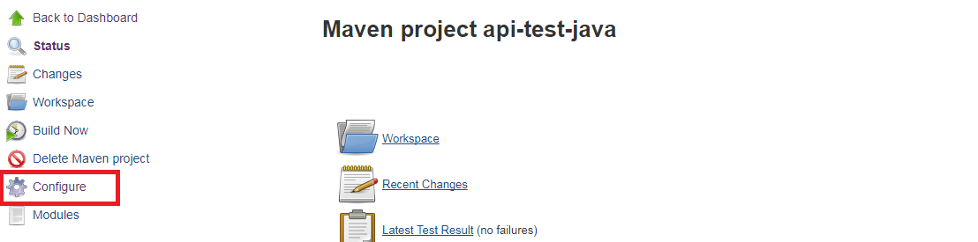

1. ConfigureRepository URL in Source Code Management.

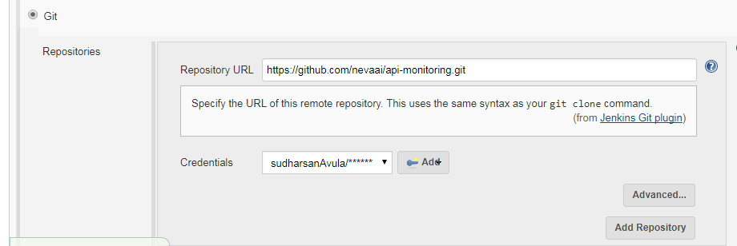

1. Provide GitHub credentials to access repository. Please find above screenshot for the same.
2. Check on “GitHub hook trigger for GITScm polling” Build Triggers

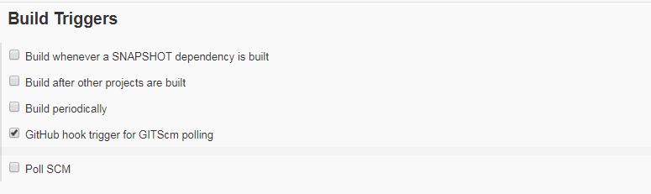

1. Click on Apply and save button.
2. From your GitHub repository, go to Settings > Integrations & Services

Click on Add Service > add Jenkins (GitHub plugin).

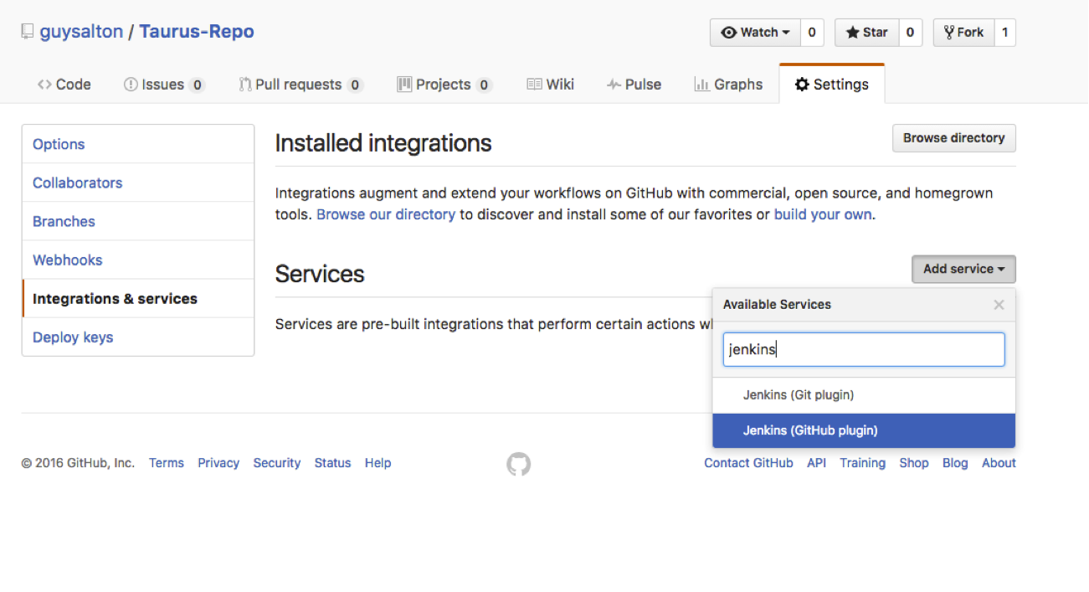

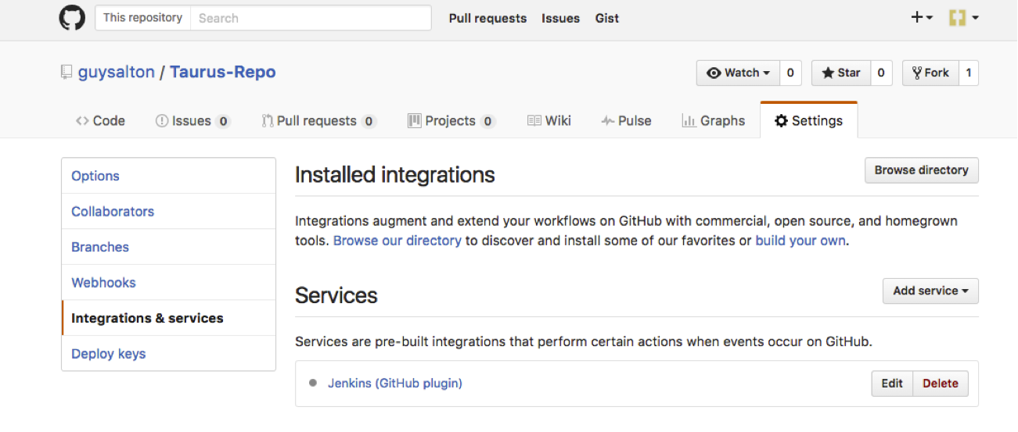

1. Set the Jenkins hook URL as the URL for your Jenkins machine, and add /github-webhook/

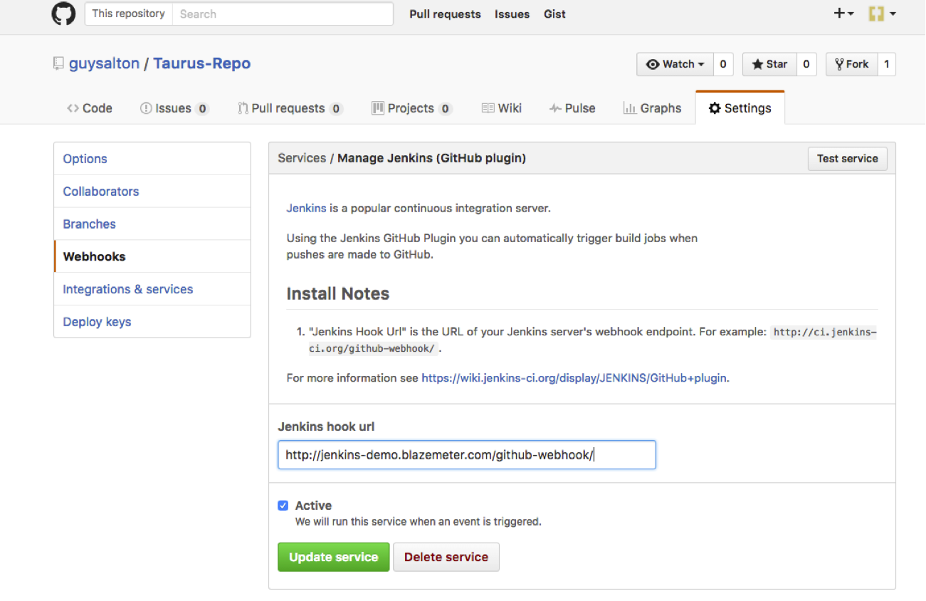

1. Click on update service.
2. Now Every time you push your changes to GitHub, GitHub will trigger your new Jenkins job.